Hi,

I need to improve a macro in VBA based on an existing file.

The file currently takes an ISBN (called ASIN in the code) from the “input” tab in the excel file and goes to the Google Play store in GB (url in the code), inserts the URL created with that ASIN and pulls certain data from that screen…
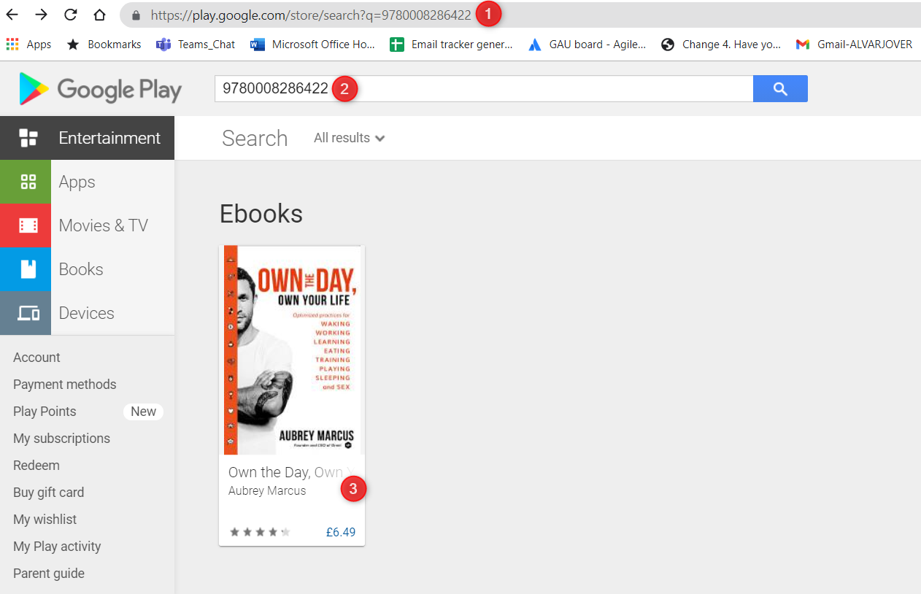

To add it in “output” tab the excel file provided.

What we need is to increase the numbers of fields captured in the excel file. For that, it will need to do the following:

- Click anywhere in the ebook card for that ASIN/ISBN
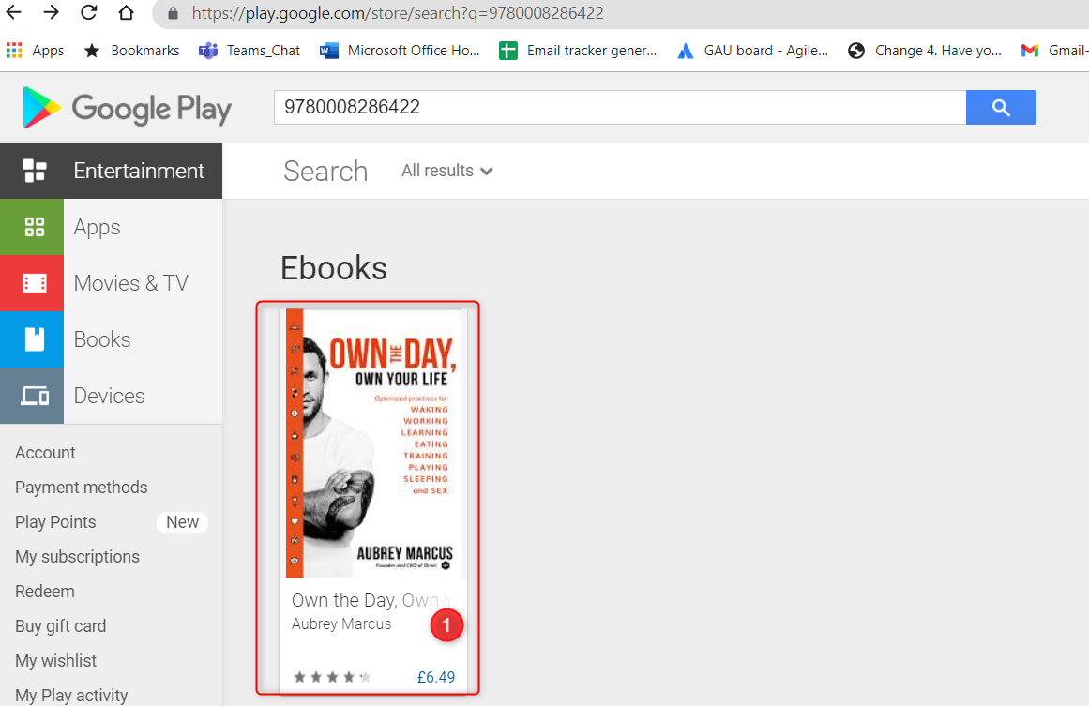

- Once you are in the Ebook product detail page, then you need to click on “Switch to Audibook”.


- That will take you to the audiobook product detail page for that product. From that page you will need to pull the following data and add it to the excel file.

- Audiobook Digital List Price: it tends to come crossed (like in the picture). If there’s no crossed price and only an uncrossed price, that’s the Audiobook Digital List Price then.
- Audibook Digital Selling Price: it’s the price next to the crossed price. If there’s no crossed price, this is also the Audio Digital List Price.


- Additional Information Section: from here we are going to pull almost all the data
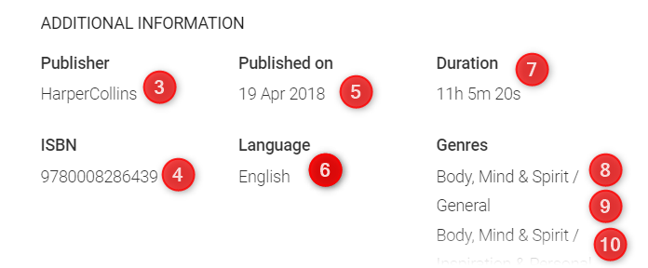
  - Publisher
  - ISBN
  - Published= format (‘dd/mm/yyyy)
  - Language
  - Duration: we need this in minutes, not hh: mm: ss. So (11*60)+5=671
  - Genre1
  - Genre 2
  - Genre 3

So the excel would look something like this (highlighted in yellow what the macro should be adding).
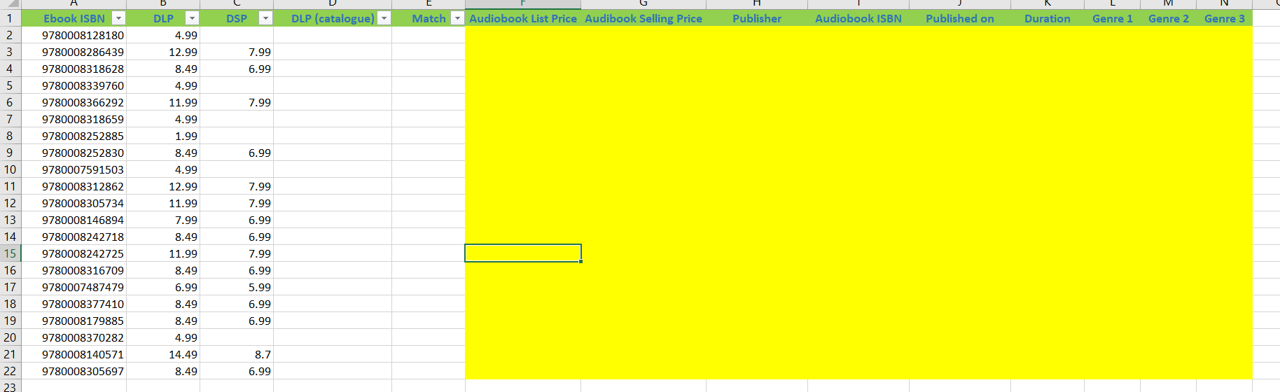

This is a loop, so the macro will have to do the above for each and every ISBN in column A.

